

AD SOYAD = BURAK HAYRAT

NUMARA = 21040101026

BÖLÜM = BİLGİSAYAR MÜHENDİSLİĞİ

KONU = DERİN ÖĞRENME FİNAL ÖDEVİ

**1. ) Naive Bayes Sınıflandırıcısı**

import pandas as pd

from sklearn.model_selection import train_test_split

from sklearn.naive_bayes import GaussianNB

from sklearn.metrics import confusion_matrix, classification_report, roc_curve,roc_auc_score

import matplotlib.pyplot as plt

veri_seti = pd.read_csv("veri_seti.csv")

X = veri_seti.drop("sinif_degiskeni", axis=1)

y = veri_seti["sinif_degiskeni"]

X_egitim, X_test, y_egitim, y_test = train_test_split(X, y, test_size=0.3, random_state=42)

nb_model = GaussianNB()

nb_model.fit(X_egitim, y_egitim)

y_pred = nb_model.predict(X_test)

conf_matrix = confusion_matrix(y_test, y_pred)

print("Confusion Matrix:\n", conf_matrix)

class_report = classification_report(y_test, y_pred)

print("Classification Report:\n", class_report)

tn, fp, fn, tp = conf_matrix.ravel()

accuracy = (tp + tn) / (tp + tn + fp + fn)

sensitivity = tp / (tp + fn)

specificity = tn / (tn + fp)

f1_score = 2 * (sensitivity * specificity) / (sensitivity + specificity)

print("Accuracy:", accuracy)

print("Sensitivity:", sensitivity)

print("Specificity:", specificity)

print("F1 Score:", f1_score)

y_proba = nb_model.predict_proba(X_test)[:, 1]

fpr, tpr, _ = roc_curve(y_test, y_proba)

auc = roc_auc_score(y_test, y_proba)

plt.figure()

plt.plot(fpr, tpr, color='darkorange', lw=2, label='ROC curve (area = %0.2f)' % auc)

plt.plot([0, 1], [0, 1], color='navy', lw=2, linestyle='--')

plt.xlim([0.0, 1.0])

plt.ylim([0.0, 1.05])

plt.xlabel('False Positive Rate')

plt.ylabel('True Positive Rate')

plt.title('Receiver Operating Characteristic (ROC) Curve')

plt.legend(loc="lower right")

plt.show()

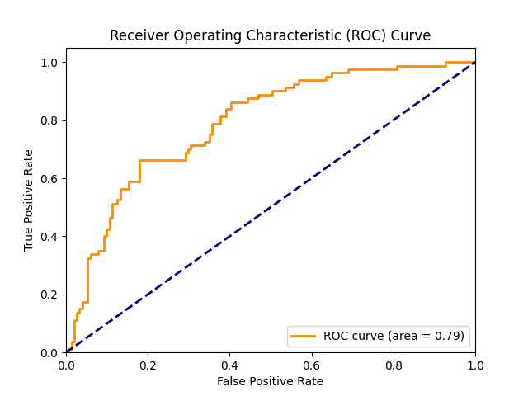

Confusion Matrix:

[[119 32]

[ 27 53]]

Classification Report:

precision recall f1-score support

0 0.82 0.79 0.80 151

1 0.62 0.66 0.64 80

accuracy 0.74 231

macro avg 0.72 0.73 0.72 231

weighted avg 0.75 0.74 0.75 231

**2) K En Yakın Komşuluk Sınıflandırıcısı**

import pandas as pd

from sklearn.model_selection import train_test_split

from sklearn.neighbors import KNeighborsClassifier

from sklearn.metrics import classification_report, confusion_matrix, roc_curve,roc_auc_score

import matplotlib.pyplot as plt

veri_seti = pd.read_csv("veri_seti.csv")

# Özellikler (X) ve hedef değişken (y) olarak ayır

X = veri_seti.drop('sinif_degiskeni', axis=1)

y = veri_seti['sinif_degiskeni']

# Eğitim ve test setlerini oluştur

X_egitim, X_test, y_egitim, y_test = train_test_split(X, y, test_size=0.3, random_state=42)

# K-en yakın komşuluk sınıflandırıcısını uygula

k_degerleri = range(1, 21) # 1'den 20'ye kadar k değerlerini dene

dogruluklar = []

for k in k_degerleri:

knn = KNeighborsClassifier(n_neighbors=k)

knn.fit(X_egitim, y_egitim)

dogruluklar.append(knn.score(X_test, y_test))

en_iyi_k = k_degerleri[dogruluklar.index(max(dogruluklar))]

print("En iyi k değeri:", en_iyi_k)

en_iyi_model = KNeighborsClassifier(n_neighbors=en_iyi_k)

en_iyi_model.fit(X_egitim, y_egitim)

y_tahmin = en_iyi_model.predict(X_test)

print("Confusion Matrix:\n", confusion_matrix(y_test, y_tahmin))

print("\nClassification Report:\n", classification_report(y_test, y_tahmin))

y_proba = en_iyi_model.predict_proba(X_test)[:, 1]

fpr, tpr, _ = roc_curve(y_test, y_proba)

auc = roc_auc_score(y_test, y_proba)

plt.figure()

plt.plot(fpr, tpr, color='darkorange', lw=2, label='ROC curve (area = %0.2f)' % auc)

plt.plot([0, 1], [0, 1], color='navy', lw=2, linestyle='--')

plt.xlim([0.0, 1.0])

plt.ylim([0.0, 1.05])

plt.xlabel('False Positive Rate')

plt.ylabel('True Positive Rate')

plt.title('ROC Curve')

plt.legend(loc="lower right")

plt.show()

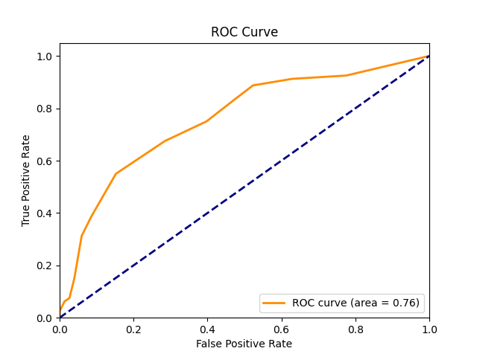

**En iyi k değeri: 13**

Confusion Matrix:

[[128 23]

[ 36 44]]

Classification Report:

precision recall f1-score support

0 0.78 0.85 0.81 151

1 0.66 0.55 0.60 80

accuracy 0.74 231

macro avg 0.72 0.70 0.71 231

weighted avg 0.74 0.74 0.74 231

**3) MLP ve SVM Sınıflandırıcısı**

import pandas as pd

from sklearn.model_selection import train_test_split

from sklearn.neural_network import MLPClassifier

from sklearn.svm import SVC

from sklearn.metrics import classification_report, confusion_matrix, roc_curve, auc

import matplotlib.pyplot as plt

veri_seti = pd.read_csv('veri_seti.csv')

# Girdi (X) ve Çıktı (y) değişkenlerini ayırma

X = veri_seti[['kac_hamile', 'glukoz_test', 'kan_basinci', 'deri_kalinlik', 'insulin_seviye', 'vucut_kitle', 'aile_diyabet', 'h_yaş']]

y = veri_seti['sinif_degiskeni']

X_train, X_test, y_train, y_test = train_test_split(X, y, test_size=0.3, random_state=42)

print("Eğitim seti boyutu:", X_train.shape)

print("Test seti boyutu:", X_test.shape)

mlp = MLPClassifier(random_state=42)

mlp.fit(X_train, y_train)

y_pred_mlp = mlp.predict(X_test)

y_prob_mlp = mlp.predict_proba(X_test)[:, 1]

print("MLP Sınıflandırma Raporu:\n", classification_report(y_test, y_pred_mlp))

print("MLP Konfüzyon Matrisi:\n", confusion_matrix(y_test, y_pred_mlp))

fpr_mlp, tpr_mlp, _ = roc_curve(y_test, y_prob_mlp)

roc_auc_mlp = auc(fpr_mlp, tpr_mlp)

svm = SVC(probability=True, random_state=42)

svm.fit(X_train, y_train)

y_pred_svm = svm.predict(X_test)

y_prob_svm = svm.predict_proba(X_test)[:, 1]

print("SVM Sınıflandırma Raporu:\n", classification_report(y_test, y_pred_svm))

print("SVM Konfüzyon Matrisi:\n", confusion_matrix(y_test, y_pred_svm))

fpr_svm, tpr_svm, _ = roc_curve(y_test, y_prob_svm)

roc_auc_svm = auc(fpr_svm, tpr_svm)

plt.figure()

plt.plot(fpr_mlp, tpr_mlp, color='darkorange', lw=2, label='MLP ROC curve (area = %0.2f)' % roc_auc_mlp)

plt.plot(fpr_svm, tpr_svm, color='blue', lw=2, label='SVM ROC curve (area = %0.2f)' % roc_auc_svm)

plt.plot([0, 1], [0, 1], color='navy', lw=2, linestyle='--')

plt.xlim([0.0, 1.0])

plt.ylim([0.0, 1.05])

plt.xlabel('False Positive Rate')

plt.ylabel('True Positive Rate')

plt.title('Receiver Operating Characteristic')

plt.legend(loc="lower right")

plt.show()

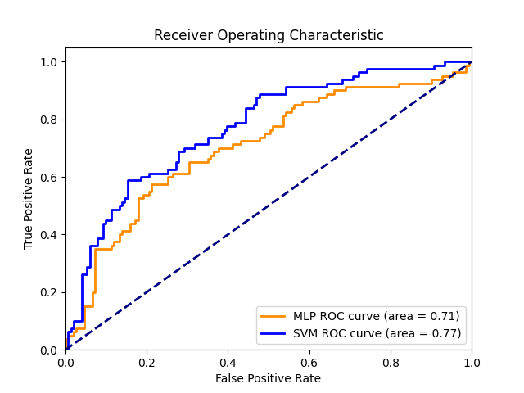

**Eğitim seti boyutu: (537, 8)**

**Test seti boyutu: (231, 8)**

MLP Sınıflandırma Raporu:

precision recall f1-score support

0 0.76 0.81 0.78 151

1 0.59 0.53 0.56 80

accuracy 0.71 231

macro avg 0.68 0.67 0.67 231

weighted avg 0.70 0.71 0.71 231

MLP Konfüzyon Matrisi:

[[122 29]

[ 38 42]]

SVM Sınıflandırma Raporu:

precision recall f1-score support

0 0.76 0.87 0.81 151

1 0.66 0.49 0.56 80

accuracy 0.74 231

macro avg 0.71 0.68 0.69 231

weighted avg 0.73 0.74 0.72 231

SVM Konfüzyon Matrisi:

[[131 20]

[ 41 39]]

**Referanslar :**

<https://www.kaggle.com/code/shrutimechlearn/step-by-step-diabetes-classification-knn-detailed>

<https://www.kaggle.com/code/amolbhivarkar/knn-for-classification-using-scikit-learn>

<https://www.kaggle.com/code/zabihullah18/diabetes-prediction>